Sources to help you with the infographics

- Health

Graph 1: https://data.worldbank.org/indicator/SH.XPD.CHEX.GD.ZS
Graph 2: https://ec.europa.eu/eurostat/web/products-eurostat-news/-/ddn-20220427-1
Graph 3: https://www.worldometers.info/coronavirus/#countries

- Environment

For the three graphs: https://ec.europa.eu/eurostat/web/environment/overview

- Politics
Graph 1: https://eige.europa.eu/genderstatistics/dgs/indicator/wmidm_pol_parl__wmid_natparl
Graph 2: https://www.statista.com/chart/20094/national-election-success-of-far-right-parties-europe/

- Education

Graph 1: : https://ec.europa.eu/eurostat/statistics-explained/index.php?title=Educational_attainment_statistics#The_populations_in_the_EU_Member_States_have_different_educational_attainment_levels_in_2021

Graph 2: possible example

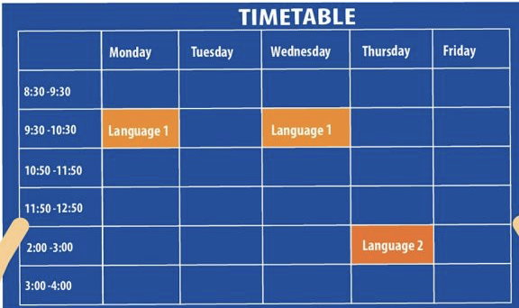

Graph 3: : https://ec.europa.eu/eurostat/statistics-explained/index.php?title=Government_expenditure_on_education

