INFOGRAPHIC

IDENTITY CARD

FLAG | NAME:
 | SURFACE:
WHERE IN EUROPE IS IT SITUATED?  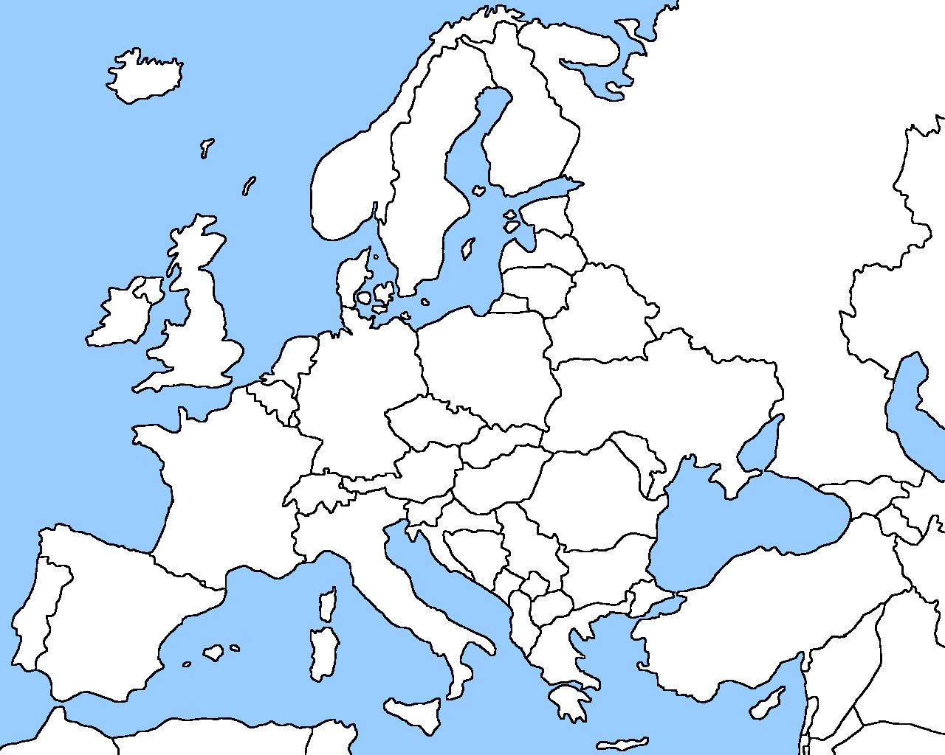 | NUMBER OF INHABITANTS:
LANGUAGES (+ percentages)
- main language:
- other official languages:

 | CAPITAL:

STATISTICS

Here we want you to describe your country with the help of numbers (graphs) concerning four themes: health, environment, education and politics.
For each theme you need to insert 3 different graphs having to do with the questions you receive.

HEALTH -  GRAPH 1 | What is the evolution of the healthcare expenditure relative to the GDP in your country in the last ten years? Compare with the European Union average.

HEALTH -  GRAPH 2 | What is the evolution in life expectancy at birth in your country (males, females) in the last ten years? Compare it with the EU average.
HEALTH -  GRAPH 3 | What is the reported Covid-19 death toll in your country? Make an infographic with the total of deaths, the deaths per 1 million people, and compare it with the European average.

ENVIRONMENT  GRAPH 1 | Make an infographic about the passenger cars (per 1000 inhabitants) and compare your findings with the EU average.

ENVIRONMENT  GRAPH 2 | Make an infographic about the greenhouse gas emissions (expressed as index 1990 = 100) and compare it with the EU average.
ENVIRONMENT  GRAPH 3 | How much of the energy used in your country comes from renewable energy? Make an infographic as % of the gross final energy consumption and compare it with the EU average.

EDUCATION  GRAPH 1 | What is the share of the population aged 25-34 with tertiary education in your country (as a % of the population aged 25-34) and compare it with the EU average.
EDUCATION  GRAPH 2 | Make an infographic with the timetable of the language education in your class. In other words, how many hours are spent on language education in your class? And what languages are taught?
EDUCATION  GRAPH 3 | Make an infographic about the expenditure on education (excluding early childhood educational development) as 1) a share of public expenditure and 2) as a % of the GDP and compare it with the EU average.

POLITICS  GRAPH 1 | What is the gender situation (men – women) in your national parliament today? Make an infographic with the situation as a percent of the total MP’s. E.g. 30% women versus 70% men and compare with the EU average.
POLITICS GRAPH 2 | Make an infographic about the result of the political parties in the last parliamentary elections. Highlight the result of the right-wing populist party.
POLITICS  GRAPH 3 | Make an infographic about the essentials of the political system in your country: Choose from the following political systems: parliamentary republic, presidential republic, constitutional monarchy, autocratic monarchy.

