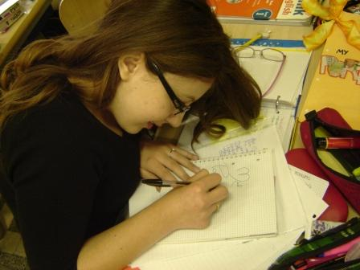

In this word document I have collected some pieces of creative writing about Rome some pupils of the Machiavelli high school have written for the Etwinning/Comenius project EMSC 1 throghout the school year 2010-2012.
My English teacher, Mrs. Fasanelli, asked me to make a selection for the EST.
Enjoy your reading!
Gaia

Piazza del Popolo (by Dalila)
It's one of my favourite places, because I think this place has something ... Magical. So, can I tell you my story?
It was 2009, or 2010, I can't remember.
I was standing all alone, a bag of Brandy in one hand and an ice tea in the other. A quiet day, sultry, typical of the summer. I was thinking. I was thinking my reflection in the fountain was beautiful, the tourists all around me.
Then I saw him. Him ...
He was wonderful. I saw him coming towards me, right from the church of Santa Maria del Popolo.
Oh, he raised a rose in his hand. Who's the lucky girl? I thought. It's not for me, of course.
I'm just his best friend.
«Hi, Dalila! I was looking for you ...»
«Hi, Michele! Really?»
«Yes, I have to tell you something ... Something special.» So my heart started to beat really fast!
«So... Well, this rose is for you!»
«Oh, thank you! It smells good! »
«I know roses are your favourite flowers...»
«Yeah...»
«So, I was looking for you because I have to tell you something... I love you, Dalila.»
«Oh... I have something to tell you too... I love you too, Michele.»
And then we kissed. The most beautiful kiss in my life.
We walked around the square and Via del Corso all day long, hand in hand.
That's why I think this place has something magical... I really love this square.
P.S.:This is a true story :)

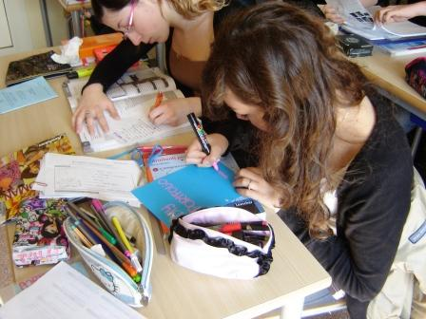

Rediscovering the eternal city. (by Benedetta D.)
Until the other day, I had never realized how beautiful being Roman citizens can be. I had always thought that being in this city was beautiful but in the end I did not care much about it. But the other day as I was walking around Rome lost in my thoughts, I met the eyes of a tourist: he was fascinated by the beauty of the many monuments in Rome, and surprised by the fact that I wasn’t. In that nanosecond for the first time in my life I felt happy to be a Roman citizen, and a bit sad about not realizing that before. Suddenly I started to really look at all the monuments that make Rome the most amazing historical city in the world. I was less prepared than a tourist. I was looking at Rome as if it was the first time. The beauty of Piazza Navona with its stalls and restaurants overlooking the area, the particularity of the Pantheon which always captivates and enchants all the tourists, the size of the Coliseum that has characterized our city for centuries, and the beautiful sky that frames these wonders. Now finally I understand how some of the greatest emperors of all times have lost their lives to defend this city knowing hat it would seduce the whole world.

That special little fountain. (by Giada B.)

Once upon a time, long time ago, a special little fountain where they say the best water of Rome flowed from. Actually there is still but people have forgotten it. It’s situated in Campidoglio square, but it’s quite hidden. Unluckily people only see what they have in front of them and don’t look for something new and almost unknown. Their attention is caught by Marco Aurelio’s statue that I think is as old as the little fountain. Seeing water running and linking it with the thought of the passing of time it’s a thing I like a lot, even if it could seem quite depressing... It’s impossible not to notice it. You only have to take as example the statue. Lots of time has passed, but we still remember what it has happened long time ago and we do this with proud, because it’s our history and we can’t forget it. It’s marvelous to personally observe what our forefathers have left to us because it’s something they did to leave a mark of them. And I have to say that I like seeing an old thing in a 21st century city, it creates a sense of time continuity like that one we see in the water’s flow, a sort of sense of immortality.

A poem about Rome. (by Camilla B.)

Rome,you never smile, but when you do that, it’s worth a life, it’s worth a full moon that take me tonight, were I understand you are my city, my heart, my hope and the centre of my memories.

A creative writing about Rome. (by Noemi C.)

From the Capitol, at the top, the breadth stop.
The view is not new, but whelms you.
Rome, you’re the most beautiful on this earth
and you’re always in my heart.

… Fragments Of Time … (by Marika F.)

Walking through its streets
You’ll walk through its history,
Breathing its air
You’ll find who you are.
Sparkles of water coming from its fountains
Touching your skin make you feel that She’s still alive.

Rome On My Scooter. (by Giulia L.)

Nothing is better than having a look round Rome on my scooter to me.
When I have one or two hours free, I take my scooter and I run from a place into other, thinking about the story of the places and my memories into them.
Before my city to me was a place like the others, only after riding experience I understood how I’m lucky to live there.

